EU Declaration of Conformity (DoC)

Hereby we,
Name of manufacturer: | LIVALL Tech Co., Ltd.
Address: | Room 904, 9F R&D Building, Shenzhen Tsinghua Hi-Tech Park, Nanshan District, Shenzhen, China
Zip code & City: | 518057 & Shenzhen
Country: | China
Telephone number: | +86 755 25951349

declare that this DoC is issued under our sole responsibility and that this product:
Product description: | Bling Helmet
Type designation(s): | BH51M Neo :57-61cm;54-58cm
Trademark: | LIVALL
Batch / Serial number:
Object of the declaration (further identification of the PPE allowing traceability; it may include a color image for the identification of the PPE):…
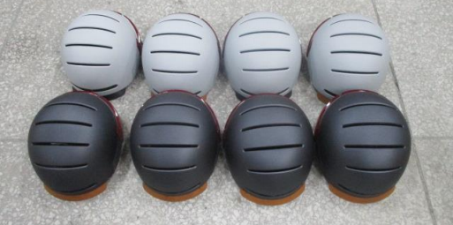

is in conformity with the relevant Union harmonization legislation:
Protective Product Equipment Regulation: (EU) 2016/425
and other Union harmonization legislation where applicable:
Performance Test
Chemical Analysis

with reference to the following standards applied:
EN 1078: 2012+A1:2012 Helmets Worn by Users of Pedal Cycles
EU REACH Annex XVII Entry 43 Azo dyes (Azocolourants and Azodyes)
pH value (EU Helmets)

The Notified Body Telefication B.V., with Notified Body number 0560 performed:
[choose applicable Modules: B ]

Where applicable:
The issued EU-type examination certificate: [note certificate number]
The conformity assessment procedure (either conformity to type based on internal production control plus supervised product checks at random intervals (Module C2) or conformity to type based on quality assurance of the production process (module D)) under surveillance of notified body (name, number).

Additional information: (accessories)
.…………………………………………………………………………………………………………
Signed for and on behalf of:
Shenzhen 09-08-2021 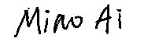
_________________________ ______________________________
Place and date of issue Name, Function, signature

